Farms to Food Banks
Appalachian Expansion Project Overview

The Farms to Food Banks program works to reduce food insecurity while strengthening Kentucky’s local food economy. The program allows for the distribution of produce that would otherwise be thrown away due to minor blemishes or size discrepancies.

Much of the Farms to Food Banks produce distributed in the Appalachian Kentucky counties has previously been transported across the state from other Kentucky farms. In fact, 27 Appalachian counties have had 1 or no farmer participants in the Farms to Food Banks program since 2011. The counties with low participation rates are as follows:
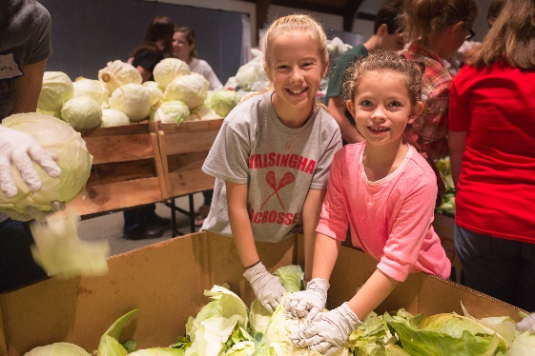
Target Counties: Bell, Boyd, Breathitt, Carter, Clinton, Cumberland, Elliot, Floyd, Green, Greenup, Harlan, Jackson, Johnson, Knott, Lawrence, Lee, Leslie, Letcher, Lewis, McCreary, Magoffin, Martin, Metcalfe, Perry, Pike, Powell, and Wolfe.

The current Farms to Food Banks program model is a market-clearing model; offers are accepted on a first-come, first serve basis and no guarantees of minimal quantities are made with any farmer. With funding from the Educational Foundation of America, our plan is to test whether offering contracts to farmers for a guaranteed amount of produce at a set price will increase participation in the region.

We will also test the feasibility of adding a new program component of processing (such as flash freezing or canning) local foods and therefore extending the number of months that it is available to the food-insecure each year. Grant funds will be used to pay processing fees.

The proposed project will:
- Allow for deeper impact in Appalachian counties in Kentucky through targeted outreach to farmers.
- Pilot the implementation of using contracts with farmers.
- Pilot the minimal processing of fresh produce to extend the number of months that families will benefit from having access to nutritious produce.
- Provide nutrition education services to consumers of the produce in collaboration with the University of Kentucky Cooperation Extension Service.

