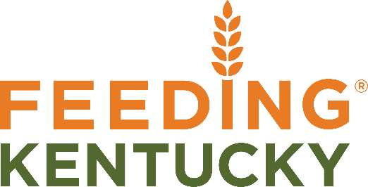
Ph. 502-699-2656 x 103
www.FeedingKY.org
produce@feedingky.org

Farms to Food Banks Crops List 2022
The 2022 prices will vary depending on market conditions and will be determined as 95% of the Kentucky produce auction market prices for US No. 2s as reported on the University of Kentucky’s website: (http://www.uky.edu/ccd/pricereports/KYPA) For general planning purposes, please refer to the chart below which shows the average price paid over the last three years. Once the 2022 season begins, current prices will be available on our website (https://feedingky.org/information-for-farmers/).

Product | Unit | Average Weight (Lbs.) | Historical Average  Unit Price | Historical Average Price/Lb.
Apples | bushel | 48 | $13.92 | $0.29
Beets | 10 # bag | 10 | $3.30 | $0.33
Broccoli | half bushel | 12 | $6.12 | $0.51
Cabbage | 50 pound bag | 50 | $8.50 | $0.17
Cantaloupe | each small (<5 lbs.) | 4 | $0.76 | $0.19
Cauliflower | head | 1 | $0.36 | $0.36
Cucumbers | half-bushel | 24 | $5.76 | $0.24
Eggplant | half-bushel | 17 | $4.08 | $0.24
Green Beans | bushel | 28 | $11.20 | $0.40
Kale | 4 lb. bunches | 4 | $1.48 | $0.37
Lettuce | half-bushel | 15 | $4.95 | $0.33
Okra | peck | 6 | $3.24 | $0.54
Onions, Candy | 10 pound bag | 10 | $2.90 | $0.29
Peaches | half-bushel | 24 | $7.68 | $0.32
Peas, Snow | bushel | 28 | $18.48 | $0.66
Pears | bushel | 50 | $14.50 | $0.29
Peppers, Bell | bushel | 28 | $7.28 | $0.26
Potatoes | half-bushel | 30 | $7.80 | $0.26
Sweet Corn | dozen | 6 | $1.68 | $0.28
Spinach | half-bushel | 15 | $6.30 | $0.42
Sweet Potatoes | 40-pound box | 40 | $9.60 | $0.24
Swiss Chard | half-bushel | 15 | $6.15 | $0.41
Tomatoes | 25 pound box | 25 | $8.75 | $0.35
Turnips | half-bushel | 25 | $8.00 | $0.32
Watermelon | each small (<10 lbs.) | 10 | $1.20 | $0.12
Winter Squash | half-bushel | 25 | $6.00 | $0.24
Yellow Squash | half-bushel | 20 | $5.60 | $0.28
Zucchini | half-bushel | 20 | $6.00 | $0.30

